Location of Bakeries: St, George, Utah Website: www.greatharveststgeorge.com

LIST PRICE FOR COMBINED LOCATIONS: $425,000

Main Store - 140 North 400 West, Ste. A-1
- Full bakery and cafe line.
- Hub store with one spoke store (Desert Hills)
- Square footage - 1964 sq. ft.
- Seating Capacity - 23 interior, 16 exterior
- Opened in 1993
- 2019 Annual Sales - $454,715
- 2018 Annual Sales - $417,807
- 2017 Annual Sales - $402,967
- Notable Equipment: Two (2) 140 qt. Hobart Mixers (one backup) w/ 8 bowls, One (1) 60 qt. Hobart Mixer w/ 4 bowls, 30 pan Reed Oven, TurboChef Sota Oven, 2005 Toyota Sienna Delivery Van, Wells Cargo 6’x10’ Trailer.
- Royalty Rate - 4%

Desert Hills Store - 922 E. Brigham Road, Bldg. 6, Ste. A
- Spoke store with full cafe line, sweets production, and bread sales produced at Hub location
- Square Footage - 1488 sq. ft.
- Seating Capacity - 26 interior, 24 exterior
- Opened September 11, 2019
- 2019 Sales (3.5 months) - $81,366
- Notable Equipment: Hobart Double Deck Rack Oven (10 pan capacity), TurboChef Sota Oven, 30 qt. Globe Mixer, .
- Royalty Rate - 4% + 2% recoverable marketing fee

Great Harvest Bread Co. first came to St. George when the city was just beginning to be noticed by the rest of the world. We have watched our city grow from a small Southern Utah town to the bustling city it is today. According to Wikipedia:

As of the 2018 U.S Census estimates, the city had a population of 87,178, and the St. George metropolitan area had an estimated population of 171,700. St. George is the seventh-largest city in Utah and most populous city in the state outside of the Wasatch Front.
In 2005, St. George was ranked the second fastest-growing metropolitan area in the United States, surpassed only by Greeley, Colorado. This trend continued through 2010, when growth slowed substantially due to the economic recession. Growth has since rebounded and St. George was declared the fastest growing metropolitan area in the U.S. in 2019. St. George ranked most secure and best place to live in the United States in 2006, and was rated among the top 10 best small cities in the country for business and careers by Forbes.

Bakery sales, along with our town, are moving in the right direction. We have built a strong set of bakeries, supported by an awesome community. Community support is a two-way street, and Great Harvest has been a proud sponsor of many City sponsored and non-profit events, including the popular St. George Marathon (Major Sponsor). We have always lived by the advice of Great Harvest Founders Pete and Laura Wakeman, “Give until it hurts, then give some more.”

Our customer base is loyal with a large part of our sales coming from regular, returning customers. Having said that, St. George is a highly toured area within driving distance to several of the world’s most popular National Parks including Zion National Park, Bryce Canyon and Grand Canyon National Park. We regularly meet customers who come in to visit, having come from a city with a Great Harvest of their own.

St. George is home to Dixie State University, an expanding institution that was just made a Division I Athletic School. A beautiful, expanding campus, coupled with the perfect climate of Southern Utah, make for an attractive destination for students and faculty alike.

One of our bakery’s most exciting areas for continued growth is in the catering sector. We have already developed a positive reputation for delicious catering, delivered exactly on time with painstaking precision in order fulfillment. Some of our best regular catering clients include Washington County School District, Dixie Regional Medical Center, and Rocky Vista University: A new medical school located in Ivins. We are currently registered with Postmates Delivery, and are exploring accounts with other popular online delivery services. Catering has an almost limitless potential, and we feel we have laid a solid foundation to capitalize on that market.

The GOLDEN QUESTION: Why are we selling our stores? Sherri and I have loved owning and operating the bakery(s) for almost 28 years. We have enjoyed financial success and personal freedom through our affiliation with Great Harvest. We have no regrets. But like all good things, we have to someday look for a graceful exit strategy. We aren’t getting any younger, and this business is continually reminding us of that fact. We are ready for the next chapter, whatever that me be. Our stores have no debt, sales are regularly on the rise, and we feel we have positioned the stores for a successful transition to the next owners who can come in and take this business to the next level!

We currently have tentative plans to remodel the main location (designing a new store has that effect). We can see a new layout in our head, but this may be something the new owners will want input on. The current layout and decor are adequate, but an update should be and could be on the horizon.

Contact: Brett Remund
Cell: (435) 632-6552
Email: gharvstgeorge@gmail.com

Boulevard Location

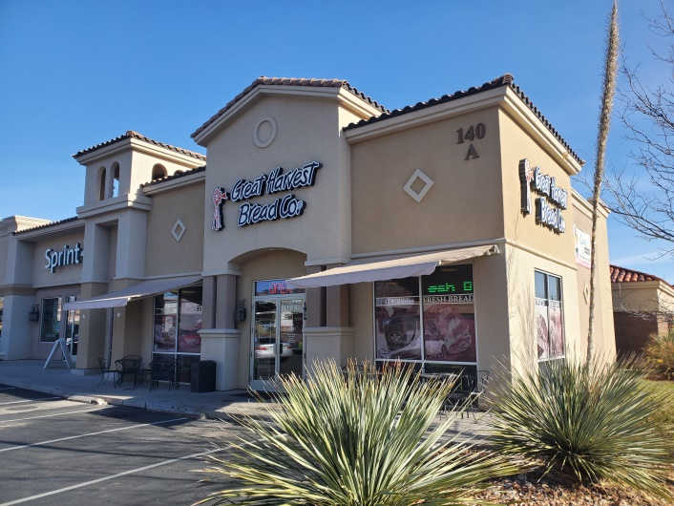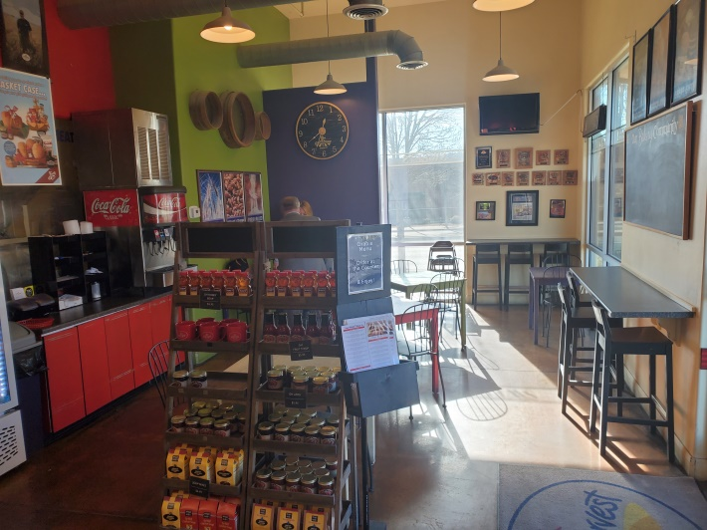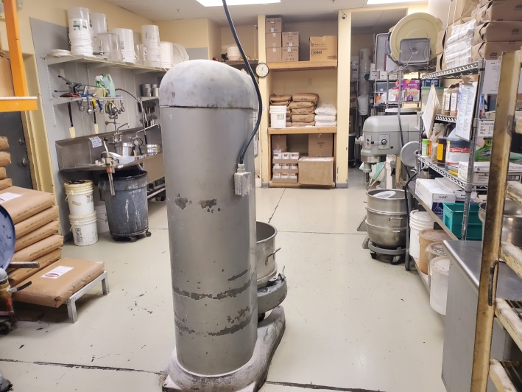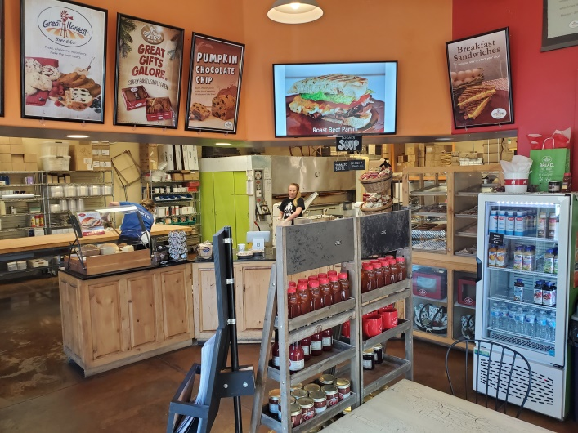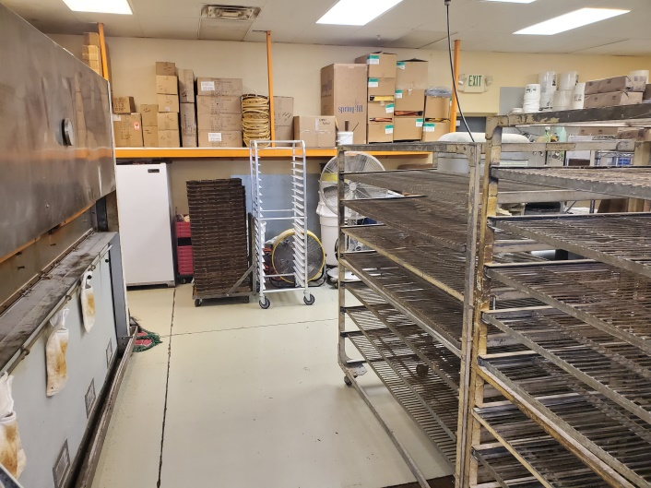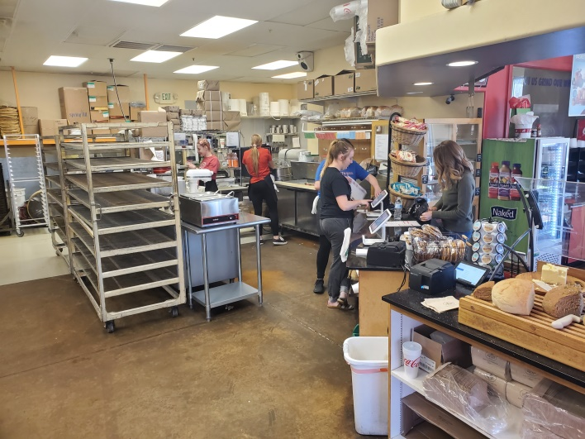

Desert Hills Location

